Impact of Password Complexity on Attacker Behavior

Joshua Huang
Nathan Li
Yemi Ogunsola
Kaleb Ward
Group 2J

HACS200: 0201
December 2, 2024

Executive Summary
This project explores the impact of password complexity on attack patterns within a honeypot environment. Password complexity is defined to be the combination of the character length, capitalization, and symbolic characters in an alphanumeric password. By developing a self-sufficient system of virtualized containers, we aimed to gather valuable insight into how varying levels of password security affect attacker behavior and the amount of time they spend interacting with a system. The aforementioned leads to our central research question: How does the password complexity of credential-secured directories affect attacker behavior and the duration of time they spend within a system?
Regarding our hypothesis, we reasoned that more complex passwords (longer passwords, capitalized letters, and symbolic characters) would significantly increase the amount of time attackers spent interacting with the system. Additionally, we hypothesized that said increase would be accompanied by an increase in the variety and quantity of commands executed by attackers. Such would suggest higher levels of interaction with the system due to the increased amount of effort required for system exploitation and data retrieval. To test these hypotheses, we configured multiple Linux containers to simulate a medical facility based at the University of Maryland. Each container possessed the same honey, or digital bait designed to attract unauthorized access, but the passwords used to secure the honey differed in complexity. Moreover, tools like iptables were used to manage connections between attackers and our system, while a recycling script ensured that the system was consistently refreshed for new interactions.
Logging capabilities were also implemented to ensure the accurate collection of data. Specifically, we focused on retrieving each attacker’s session duration, the commands they executed, and the IP associated with the attack. The metrics gathered allowed us to develop general conclusions about attacker behavior, but there was a lack of direct interaction between attackers and the honey placed in each container.
The general conclusions from the data showed that attacker duration does depend on the complexity of the configuration if attackers are not allowed to repeat sessions. Likewise, high complexity passwords do have a significant impact on the number of commands. The collected data also revealed that most attacks were automated, meaning they originated from bots instead of human actors. The bots tended to execute pre-programmed scripts that ran commands mainly associated with retrieving the system information and removing and editing permissions, regardless of the honeypot’s configuration. Such commands further justify the lack of interaction with the honey across all configurations.
Background Research
Password complexity and strength are some of the most popular and continuously growing cybersecurity topics. As more digital technologies and products are created, the need to secure information and data increases exponentially. Different techniques to secure data, such as biometric authentication, multi-factor authentication, graphical passwords, and more, have become prominent. However, the single-factor alphanumeric password is still the most common security method (Grassi, et al.). The standard password scheme includes creating a password, encrypting the password, and storing the cipher or hash text. At the next login attempt, the password’s encrypted hash will be compared to the cipher for a successful login (Grassi, et al.).
A password is a gateway to private and public information, and as a result, password cracking has become a problematic area to prevent breaches from attackers who progress new methods and techniques. Password cracking can be defined as the process of recovering the original password from the cipher text. Cybersecurity measures to prevent stolen data include longer passwords, alphanumeric characters, and string randomization (Sahin et al.).
The key question is what makes a password good. Password complexity and password strength are two main factors that can influence a “good” password. Password complexity is defined as “the usage of allowed characters, length, and symmetry of a password,” and password strength is defined as the number of attacks necessary for an attacker to crack a password (Sahin et al.). Password strength, unlike complexity, takes into account the attacker’s knowledge, cracking techniques, and previous success (Sahin et al.).
In this experiment, password complexity was grouped into four categories: no complexity, low-complexity, medium-complexity, and high-complexity. The no complexity group has no password. Low-complexity passwords are three characters long and lowercase alphabetic only. Medium-complexity passwords are six characters that are alphanumeric, with one symbolic character, one capitalized character, and relate to a common English word (e.g., P3ac$). High-complexity passwords are nine-character passwords that have two symbolic characters, two capitalized letters, and do not relate to a common English word (e.g., Xylo#9Rt!).
Attackers use a wide range of methods and techniques to crack a password. The most common is the brute force method, which continuously attempts different passwords from a vast alphanumeric set until the correct password is accepted. Attackers use a wide range of methods and techniques to crack a password. A well-known technique is the brute force attack with password crackers like Hydra; however, this method takes a lot of time and computational effort that many attackers cannot afford when inside a system. Therefore, other methods, such as dictionary attacks, which use common words, and rainbow tables, which are massive tables that map common passwords and symbols to their respective hashes, have become more common (Yu and Huang, 2015).
Similar research has been conducted on the relationship between password length and crack times. Cazier and Medlin applied a cracking tool, L0phtCrack 5, to an e-commerce website password dataset and analyzed the subsequent crack times (the time it took for a password to be cracked) and the cracking method (brute force, dictionary, etc) to figure out the password from the respective cryptographic hash code. The average password of the 520 users was 7-8 characters, and the average time it took to crack 516 (4 were not able to be cracked) was 38 hours. The median crack time of 3.85 hours provides a better overall look at the data. Most of the passwords were cracked using the dictionary method, and in addition, passwords were cracked in either less than a minute or over one hour. Alpha character-only passwords (weak passwords) were cracked in less than a minute, while the addition of special characters extended the crack time to at least 1 hour. They modeled the crack time and length as a regression equation shown below
$Crack time = 12.93 hours × password length - 56.83 hours$
The equation shows that the crack time increases by 12.93 hours for every character added to the password length (Cazier Medlin). As a result of this study, the maximum timeout in the system was set to 30 minutes to balance receiving as many attacks as possible and allowing an attacker enough time to cycle through the initial beginnings of a password-cracking technique.
In this study, it is assumed that the attackers interacting with the honeypot have varying skill levels and motivations (Sahin et al.). It is also assumed that the security layers deployed within the honeypot (like user roles and password protection) are capable of influencing the behavior of attackers (Yu and Huang). For example, an attacker’s method depends on whether they want admin access or multiple-user access. For admin access, an attacker can employ the deep search method and look for specialized information for that specific user. On the other hand, for multiple-user access or lower-level access to a system, they may cast a wide net with a common alpha character-only password and wait until at least one user’s password has been cracked.
Experiment Design Changes
The 15-week project was designed to simulate a University of Maryland healthcare center with valuable data stored within password-protected directories. We originally wanted to implement a honeypot with various security measures per configuration, such as firewalls, antivirus, and passwords. After explaining our project in class, we received instructor feedback that helped us determine what we wanted to define security as. Ultimately, we made revisions and narrowed down the scope to address our revised research question: How does the complexity of password-protected directories impact attacker behavior?
Throughout the semester, we made several modifications to the design of our experiment. Initially, we created four containers (one for each configuration) to handle the research question, as we were under the impression that we were only to be assigned four IP addresses. However, we received five, so in week nine, we created a fifth container to account for the fifth IP address we were provided. This change allowed us to accommodate more attacker connections, but resulted in a 95% disk usage for the virtual machine. Each container had four unique snapshots (20 total), but within the same week, we reduced this to just four shared snapshots. Instead of stopping, restoring, and restarting containers, we transitioned to destroying and re-creating them using these snapshots. This adjustment significantly conserved disk space and simultaneously made the recycling process more efficient.
Moreover, before deployment in week eight, we refined our recycling script to check for three conditions: when the attacker disconnects, when idle time exceeds five minutes, or after 30 minutes of connection. This update replaced the initial single-timer approach and allowed for more accurate and responsive recycling, improving the reliability of our data.
Furthermore, the recycling script was initially called via a crontab with a one-minute interval (the lowest allowed by cron). However, this left a decently large window for other attackers to log into our containers while an attacker was already interacting with the system. To prevent this, we constructed a while loop that allowed the script to execute every 10 seconds, ensuring faster recycling and minimizing idle periods.
Prior to deployment, we also planned to use a tool called ecryptfs to secure directories, but compatibility issues prompted a switch to another tool called zip which was compatible with the Linux system. The transition did not impact the strength of the password-protected directories.
Regarding data collection, a script called importFile.sh (Appendix C.I - Figure 2) was created the week of deployment to automatically organize Man-In-The-Middle (MITM) logs, improving efficiency and post-attack analysis. The script worked in tandem with a Python script, parseLog.py (Appendix C.I - Figure 6), created in week nine to parse logs received from the MITM server and extract key metrics such as snapshot configuration, session duration, and command history. The latter script gave us a more detailed analysis of the data we collected and improved data organization.
Apart from dividing the task of recycling into multiple scripts, we worked on involving the automatic setup of the environment, utilizing a tool called crontab. We ensured that basic functionality, such as firewall rules and container setup, would be preserved upon reboot of the host system.
Lastly, we implemented a way to account for repeat attackers, as we found that multiple attackers were taking up considerable amounts of our total logs (1000+) during the week of deployment. We manually and continuously added iptable rules to block the IPs of these excessive attackers, spanning from week nine to fifteen.
Research Question and Hypothesis
As mentioned above, we aimed to answer the following research question: How does the password complexity of credential-secured directories affect attacker behavior within a system? Attacker behavior is defined as the type, number, and frequency of commands and password-cracking techniques used by an attacker. Attacker behavior influences the duration an attacker spends in the system; hence, this will also be studied.
It was hypothesized that the highest frequency of the types of commands we would see by an attacker would be file management commands that create, view, and edit files and directories. File management commands are the most common commands executed because they allow for system navigation and are necessary for the attacker to be aware of the password-encrypted directories. It was also hypothesized that the number of commands and the amount of time an attacker spends within the system would increase as the password complexity increased. More complex passwords take longer to crack and would require more effort on the attacker’s part to break in (Cazier Medlin). We reasoned that stronger, more complex passwords would deter attackers, as they take significantly longer to crack compared to simpler password requirements (Cazier Medlin).
The null hypothesis formulated for this experiment was that the password complexity of credential-secured directories would not affect attacker behavior within a system. Furthermore, this would suggest that other factors may be of influence, or attackers will remain consistent in their interaction span regardless of password complexity.
The alternative hypothesis for this experimentation is that attacker behavior would significantly change as password complexity increases. In particular, file management commands, types of password-cracking techniques, number of commands, and attacker duration in the environment would increase.
Experiment Design
Our honeypot mimics a UMD Healthcare center with medical-centric data stored within password-protected directories. Five containers (for each given IP address by the university) were created utilizing one randomly chosen configuration out of four: Control, Low-complexity, Medium-complexity, and High-complexity. The Control configuration had no passwords assigned to the directories. Low-complexity passwords were three characters long and lowercase alphabetic only. Medium-complexity passwords were six characters, alphanumeric, one symbolic character, one capitalized character, and related to a common English word. High-complexity passwords are nine-character passwords with two symbolic characters, two capitalized letters, and do not relate to a common English word (Appendix C.I). Each directory was assigned a unique password based on low, medium, and high complexities.
A template container was created that contained the original snapshots of each configuration. OpenSSH and the zip package were installed on the container. The directories were downloaded into the virtual machine from a host laptop and moved into a template container. A snapshot was taken of the container with the non-encrypted directories, which was the Control configuration. Next, the passwords of one configuration were manually assigned to the directories using the zip command and the corresponding passwords for each directory. A snapshot of the template container was taken, and the control configuration was restored to the template container. This process was repeated until all four configurations had a unique snapshot on the template container.
An MITM server monitored each container. The four main scripts are cronSetup.sh, mitmNAT.sh, recyclingScript.sh, and importFile.sh. The cronSetup.sh (Appendix C.II - Figure 4) script sets up everything on reboot, including setting up the iptable rules for forwarding and receiving packets to the MITM process, firewall rules, deleting and recreating the five containers with IP addresses, and blocking repeating attackers. This script is necessary in the case that the host virtual machine has to be rebooted for some reason.
The mitmNAT.sh (Appendix C.II - Figure 5) script sets up an MITM server for each container, so a unique MITM port is assigned to each one and remains consistent throughout the study. The MITM server is used because it operates outside the container, unlike keyloggers like Snoopy, making it significantly harder to detect. The MITM servers are all forever processes, and each container is connected to one MITM server, so each container has one MITM log that contains all of the attempted and successful connections. Once an attacker is connected to a container, the MITM port, attacker IP, and configuration of the container are echoed into the MITM log to keep a record of the attacker and the system environment.
The importFile.sh (Appendix C.II - Figure 2) script transfers the specific portion of the MITM log for a successful connection to its configuration directory by grepping for the configuration in the MITM log between the most recent attacker’s successful connection and disconnection. The filename of a log contains the date, timestamp, and configuration name for successful connections.
Finally, the recyclingScript.sh (Appendix C.II - Figure 1) utilizes the mitmNAT.sh and importFile.sh. The NAT rules were set up for multiple conditions for when a container should recycle after an attacker successfully enters the honeypot: 30-minute max timeout, 5-minute idle time (non-interactive attacker), and when the attacker exits. Immediately, when the attacker enters a container, all IP addresses from the Internet are blocked, so the attacker is the only one who can access the honeypot. If a condition is met, the container goes through the recycling process. The reason for recycling or closing a connection is echoed in the MITM log for the container so we know if and which of these conditions are met for maintenance purposes. On recycle, the NAT rules for the container are dropped, and the container is deleted from the host virtual machine. At the end of the recycle, a new container is created with a configuration, the same IP address as before the deletion, and NAT rules set for forwarding and receiving information.
For the randomization of the four configurations, we needed to minimize the storage space of the snapshots to monitor the health of the containers in NetData and run the virtual machine in general. The template container holds the original snapshots, and the LXC snapshot arguments were utilized to restore a randomized configuration from the template container to a new container. This randomized configuration is chosen within the recyclingScript.sh script by calling one of the four configurations.
To finish everything up and allow the script to automate, we have one final script, called container1Recycle.sh (Appendix C.II - Figure 3), that runs on reboot and runs each container through the recycling script independently every couple of seconds to check if the container is ready to be recycled.
Data Collection
The primary data calculated was the attacker’s commands inside the honeypot, including exact command(s) and quantity, along with the duration of time (in milliseconds) from when the attacker successfully connected to the server, and when the attacker exited the honeypot. Supporting data such as the attacker’s IP address, MITM Port, and the environment's configuration were also collected for each attacker session.
The data was all collected using an MITM server to collect the logs for each attacker, which contained the commands and time stamps of the attackers. The MITM logs from each successful connection were parsed through a Python script (Appendix C.II - Figure 6) to extract the attacker duration and the commands used. The logs were uploaded into a Google Colab script (Appendix C.III), which was compiled from individual sessions into a total database that considered all the information mentioned above. Overall, 31,370 total data points were collected throughout the course of four weeks, along with 5.897 data points of individual successful attacker connections. The logs from each week were compiled into an extensive database. The duration of some sessions was null or N/A, defined as the attacker immediately entering and exiting in less than a couple of milliseconds. All 1542 sessions that had a duration that was Null or N/A were eliminated. The MITM port monitored a unique container IP address that was consistent throughout the study. The number of sessions for each MITM port was collected to determine if any IP addresses were not working properly or receiving the same number of attacks as the other containers (Appendix C.III).
The raw data labels were changed to reflect the common name; for example, the configuration names were changed from snap0 to Control. Two main data frames were created from this cleaned-up dataset. The first data frame contained all the attackers, regardless of repeated attempts, and the second data frame contained only the first instance of an attacker’s attempts. This filtering process was done by taking the first instance of an attacker’s IP address and the corresponding session data. This process was necessary because there were attackers who successfully connected to the environments over 1000 times with the same commands, duration, and other data points. The unique filter eliminated 24,782 data points from the total data set (Appendix C.III).
For both the total and unique data frames, the data was divided by the environment's configuration: Control, Low, Medium, and High-complexity, which depended on the complexity of the passwords within the honey. These configurations were the system's independent variables, and hence, the dependent variables were compared between them.
The idle time for the system was five minutes, and due to the minimal number of attackers actively entering commands above that time limit, any attacker who had a duration of over five minutes was eliminated from the dataset. This was done to ensure these outliers would not skew the data. In addition, the commands used in the attacks over five minutes would not significantly impact the research question itself, as they happened to be the same commands as the attacks in less than ten seconds. Overall, twenty-two data points were eliminated in the total dataset and five data points were eliminated in the unique dataset.
The data was interpreted in various ways such as each attack session’s duration and number of commands executed. A graphical and statistical analysis of the data was curated for both dependent variables mentioned. The types of commands pertinent to the research question, such as cd, ls, zip, unzip, and cat, were also filtered through the attacker commands. The types and frequency of commands an attacker used inside a configuration were also observed.
Data Analysis
The data for this experiment was analyzed using a visual analysis with a violin and box plot for each configuration in this experiment. The configurations were the independent variables; therefore, the attacker behavior as the dependent variables across the configurations could be analyzed. A graphical or visual representation of the data helps provide support for the statistical analysis used for each test. In addition, it helps to see how the data was distributed across the range because statistical analysis methods do not provide that insight. Statistical analysis provides definitive and mathematical proof behind the conclusion that visual analysis can falsely represent such equivalent averages between two populations.
For the duration of attackers, only attack sessions lasting less than five minutes were analyzed. Out of over 30,000 attacks, only twenty-two were over five minutes, less than 0.01%. Less than 1% of attacks were over two minutes; however, the attacks above two minutes had unique commands and were the first instance of an attacker so they were kept to keep the variation in data. As a result, all attacks above five minutes were removed from the resulting analysis in both the visual and statistical analysis for the duration of attackers. Graphical and statistical methods were used for both the total and unique datasets. The total dataset was necessary to understand the attack patterns of all the attackers who entered the environment regardless of repeat attempts. The unique dataset helped remove repeat attackers, eliminating data points and increasing the significance or weight of the data points left over.
Throughout the weeks of collecting data, it was visually seen in the graphs that the majority of attackers had a duration of less than ten seconds in the environments for each configuration. In fact, many attackers had a duration of zero seconds (immediately exiting after entering) that resulted in lowering the averages of the dataset to fall closer to zero for each configuration (Appendix B.II).
There was a trail of data points from ten to seventy seconds for each configuration, but these data points were less than 5% of the total data points for each configuration. A clump of attacks is seen around sixty seconds, and the trail of attackers stopped around sixty-five seconds (Appendix B.II - Figure 5). Overall, the majority of data points and attacker durations were less than ten seconds (Appendix B.II - Figure 5). This behavior was presented primarily in the total attackers and the unique attackers. The unique attackers had a majority of attacks that fell beneath ten seconds and the minority of attacks that were between ten and seventy seconds was not present for all configurations (Appendix B.II - Figure 4).
The number of commands that the attackers used in the environments followed a similar pattern to the duration of attackers. The number of commands is an integer, unlike the duration of an attacker, which led to a different violin shape than the one for attacker duration. However, the majority of the number of commands was less than six, regardless of the configuration. There were attacks scattered between ten and forty commands, but these were a minority compared to the commands that fell below six seconds (Appendix B.III - Figure 7). The unique number of commands for the first instance of an attacker’s IP address was similar to the total number of commands for the total dataset. Most attacks had less than six; however, the number of commands for the high complexity configuration did not reach above ten, unlike the total dataset that reached to thirty-three (Appendix B.III - Figure 8).
The Kruskal-Wallis and ANOVA tests were performed to reject the null hypotheses. The null hypothesis for the duration and number of commands was that there was no significant difference between the means of each independent configuration when focusing on each response to the configuration. The p-value of the level of significance for all the weeks combined was 0.10. The higher p-value was necessary to take into account for the spread of the dataset over 30,000 and not allow the natural variation in the dataset to skew the p-value, and hence, consistently accept the null hypothesis. The Kruskal-Wallis and ANOVA tests were done by comparing the independent variables, configurations (Control, Low, Medium, and High), to the dependent variables (duration of attacks and number of commands). If the p-value from the Kruskal-Wallis test was less than the significant level, the Dunn test was used. The same applies to the ANOVA test, where the Tukey HSD test was utilized if the p-value was less than 0.05. For the attacker duration, only sessions under five minutes were used in the statistical tests.
For the total dataset for the compiled four weeks of attacks with repeat attackers, the ANOVA test had a p-value of 0.7965, and the Kruskal Wallis test had a p-value of 0.239. The null hypothesis for the total dataset cannot be rejected for the ANOVA and Kruskal-Wallis Test. For the unique attacker for the compiled 4 weeks of attacks, the ANOVA test had a p-value of 0.0008, and the Kruskal-Wallis test had a p-value less than 0.0001 (Appendix B.I - Table 1). The subsequent Tukey Test showed that the Control and Low configurations had a p-value of 0.0030, the Control and Medium configurations had a p-value of less than 0.0001, and the Control and High configurations had a p-value of 0.0002. The subsequent Dunn test showed similar results, where the Control and Low, Control and Medium, and Control and High had p-values less than 0.0001 (Appendix B.I - Table 2). The null hypothesis for all four configurations can be rejected for the ANOVA and Kruskal-Wallis test.
The number of attacks for the compiled four weeks of attacks with repeat attackers had an ANOVA test with a p-value of 0.205 and a Kruskal-Wallis test of 0.53. The null hypothesis cannot be rejected for the ANOVA and the Kruskal-Wallis test for any of the four configurations. For the number of attacks for the unique attackers compiled over the four weeks, the ANOVA test had a p-value of 0.0613, and the Kruskal-Wallis test had a p-value of 0.001 (Appendix B.1 - Table 1). The subsequent Tukey Test showed that the Control/High had a p-value of 0.003, and Control/Low and Control/Med had p-values above 0.10. The subsequent Dunn test showed that the Control/Low had a p-value of 0.0254, the Control/Medium had a p-value of 0.06317, and the Control/High had a p-value of 0.00928. The null hypothesis can be rejected for the Control/High for both the ANOVA and the Kruskal-Wallis test, but only the Kruskal-Wallis rejects the null hypothesis for Control/Low and Control/Medium (Appendix B.I - Table 3).
The most frequent command used 8012 times was uname -s -v -n -r -m, which is a command to find the system information. The second most frequent command used was cd ~, chattr -ia.ssh; lockr -ia.ssh . This command sequence puts the attacker in the home directory and removes all the locks and permissions that could lock the .ssh directory. The command apt, which is used to install packages, was used 202 times. The commands cat, more, less, tee, and exit were used in combination over 190 times to read file content. Interestingly, a filename was never provided for these commands. Finally, the last types of commands used over 100 times included a link with the commands wget or scp, which are used to download and retrieve files from the Internet or the host computer (Appendix B.IV - Table 1). The null hypothesis was not rejected for this study because although a majority of the commands were used to edit or view files and directories, no commands directly interacted with the directories or files in the system.
Justification and Conclusion
From these findings, multiple conclusions can be drawn. For attacker duration and number of commands, the unique dataset results in statistical significance between the configurations, while the total dataset does not. The repeated attacks, as many as 1000 from one attacker, with repeated durations and number of commands significantly skew the dataset, which resulted in the large p-values for the total dataset. However, by removing these repeated attacks, the weight of each attack increases and the data can reflect each unique instance for attackers. Therefore, the unique datasets will have a statistically significant difference.
There is a high level of confidence in rejecting the null hypothesis for the duration of attacks for a unique dataset is statistically significant, showing a difference for Control/Low, Control/Medium, and Control/High because both the ANOVA and Kruskal Wallis Test gave extremely low p-values, and this was corroborated by the Tukey Test and Dunn Test respectively. On the other hand, the number of attacks had p-values that were relatively closer to 0.05, and the higher p-values compared to the duration of attacks were seen in the different results from the Tukey and Dunn test. The Tukey test and Dunn test both rejected the null hypothesis for the Control/High, so there is high confidence in that conclusion; however, the Dunn test rejected the null hypothesis for the Control/Low and Control/Medium with relatively higher p-values than its Control/High counterpart. Therefore, more tests would have been performed on the number of attacks for a unique dataset to draw a confident conclusion that there is a statistically significant difference between the means for the Control/Low and Control/Medium.
The overwhelming majority of commands were uname commands to identify system information, followed by other commands, such as simple commands like cd or cat, to attempt to manipulate root access using commands such as chattr -ia .ssh and lockr -ia. Ssh. The number of commands for the unique dataset decreased as the complexity of the configurations increased; however, since no commands interacted directly with the honey, the research question cannot be answered.
It was also observed that attackers seem to use automated bots to help gather information on a system, which can explain the system information command being first. It was interesting to note that many attackers would repeatedly and successfully enter the containers over 1000 times, and the attackers would perform the same commands. Although there was a 30-minute max timeout to allow attackers enough time to interact with the password directories, most attacks were not above 5 minutes; in fact, most attacks were below 2 minutes. In addition, attackers did not interact with the honey or password-encrypted directories at all, which severely limited the analysis of the project in relation to the research question.
Based on our logs, if we could do the experiment again, we would detail our research question around interaction with the honeypot itself, rather than just the honey contained within the containers. Although none of our attackers interacted with the honey, we did have some logs about attempts to enter the container that suggested some dictionary attacks and other brute-force attempts to break into the container, which could have produced potentially statistically significant results.
In conclusion, the configurations did have a significant effect on attacker duration for the Low, Medium, and High-complexity configurations when compared to the Control. The number of commands had a significant effect on the High-complexity configuration when compared to the Control. While the Dunn test said there was a significant effect of Low and Medium when compared to Control, Tukey gave conflicting results. Therefore, more testing would have to be performed to gain higher levels of confidence in this conclusion. Based on the data we have collected, we conclude that while password complexity is an important aspect of cybersecurity, its effect on automated attacks is limited.

Appendix A
As mentioned before, our biggest failure was any interaction with the honey itself. Although we were able to get some statistically significant results regarding the duration an attacker spends within our system, none of our attackers actually attempted to crack into our password-protected directories, meaning our experiment could yield limited results.
Overall, we were surprised by how much interaction we got within our containers, particularly by bot accounts. Some users would continually interact with our honeypots by entering and reentering them, with one user doing so more than 1500 times. It got to the point that we had to filter out these IPs to prevent them from skewing our data, as they would enter, call a single command (usually uname), and then exit and repeat the process.

Appendix B
Appendix B.I
- Statistical Results
Table 1 ANOVA and Kruskal-Wallis Test for the four studies including duration and number of commands for all attacks and unique attackers
Experiment | ANOVA |  |  | Kruskal Wallis Test
 | p-value | F-statistic | Reject Null Hypothesis | p-value | H-statistic | Reject Null Hypothesis
Duration of Attacks for All Attackers | 0.797 | 0.339845 | FALSE | 0.239 | 4.32 | FALSE
Duration of Attacks for Unique Attackers | 0.00008 | 8.819 | TRUE | > 0.00001 | 78.91 | TRUE
Number of Commands for All Attackers | 0.2049 | 1.528 | FALSE | 0.911 | 0.53 | FALSE
Number of Commands for Unique Attackers | 0.0613 | 2.454 | TRUE | 0.001 | 15.87 | TRUE

Table 2 Tukey Test and Dunn Test for the duration of attacks for unique attackers. The statistical differences between the control and low, medium, and high are the highlighted ones shown in the table.
Duration of Attacks for Unique Attackers | Tukey Test |  | Dunn Test
 | p-value | Reject Null Hypothesis | p-value | Reject Null Hypothesis
Control & Low | 0.0299 | TRUE | > 0.00001 | TRUE
Control & Medium | 0.0004 | TRUE | > 0.00001 | TRUE
Control & High | 0.0003 | TRUE | > 0.00001 | TRUE

Table 3 Tukey Test and Dunn Test for the number of commands for unique attackers. The statistical differences between the control and low, medium, and high are the highlighted ones shown in the table.
Number of Commands for Unique Attackers | Tukey Test |  | Dunn Test
 | p-value | Reject Null Hypothesis | p-value | Reject Null Hypothesis
Control & Low | 0.5118 | FALSE | 0.02544 | TRUE
Control & Medium | 0.5221 | FALSE | 0.063716 | TRUE
Control & High | 0.0498 | TRUE | 0.009283 | TRUE

Appendix B.II
- Duration of Attacks Over the Course of 4 Weeks
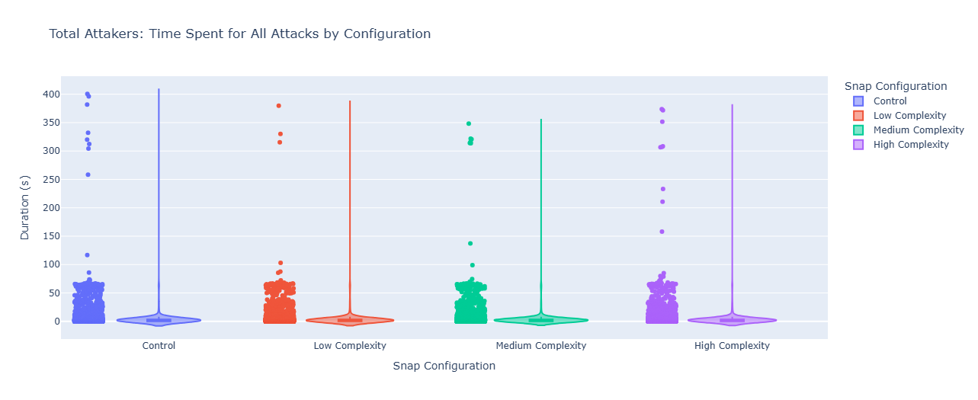
Figure 1 Duration of attacks for all attackers for the various password complexities over the course of four weeks.
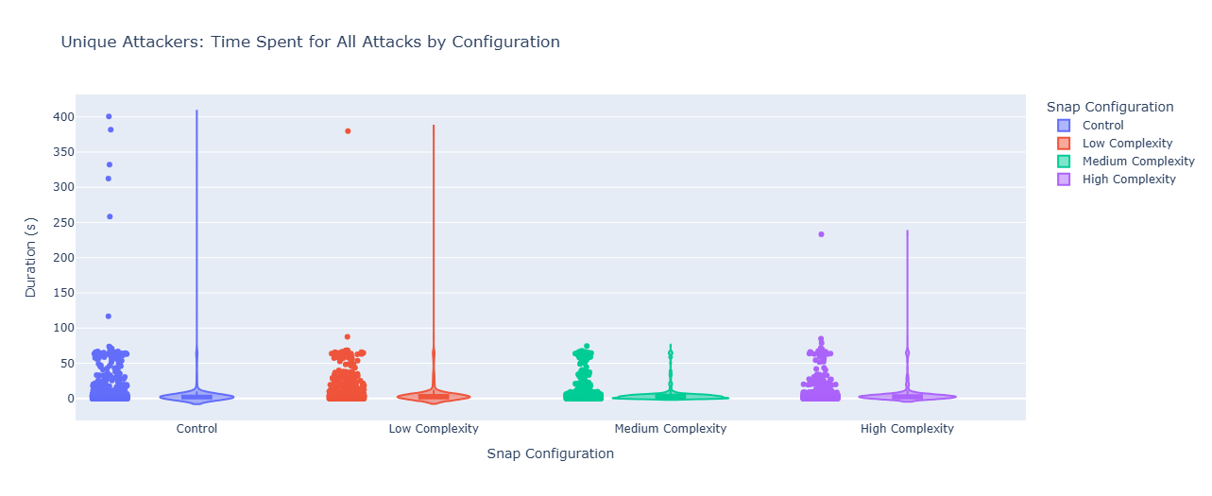
Figure 2 Duration of attacks for unique attackers (first instance of an attacker IP address) for the various password complexities over the course of four weeks.

- Duration of Attacks Less than 5 min
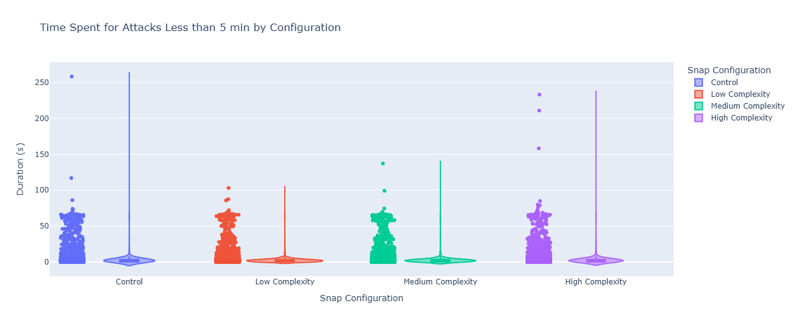
Figure 3 Duration of attacks less than 5 minutes for total attackers for the various password complexities over the course of four weeks.
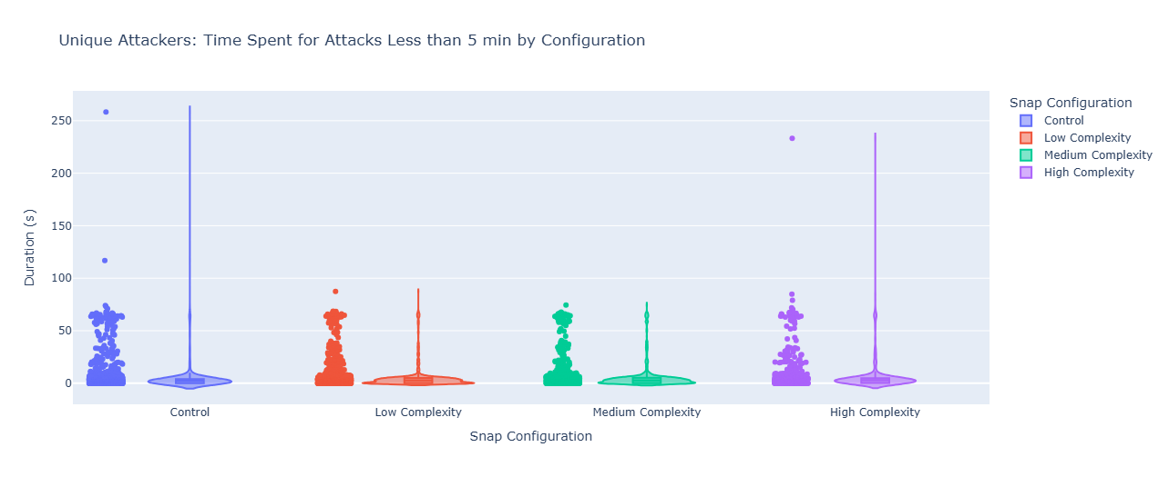
Figure 4 Duration of attacks less than 5 minutes for unique attackers (first instance of an attacker IP address) for the various password complexities over the course of four weeks.

- Duration of Attacks Less than 2 minutes
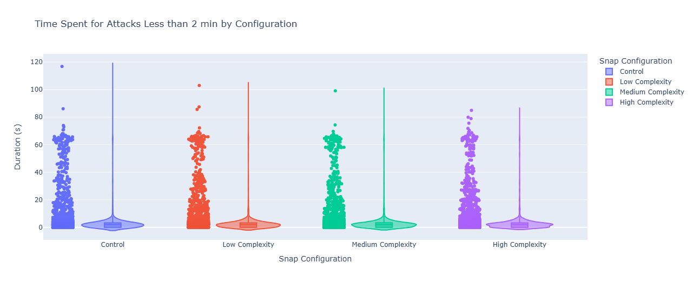
Figure 5 Duration of attacks less than 2 min for attackers for the various password complexities over the course of four weeks.
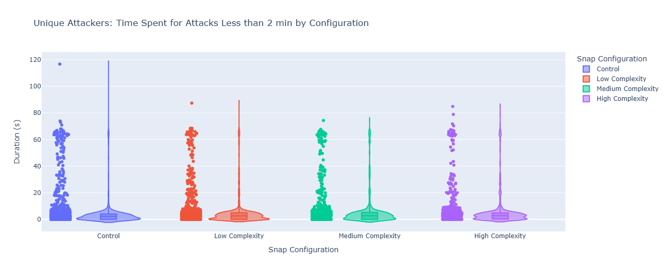
Figure 6 Duration of attacks less than 2 minutes for unique attackers (first instance of an attacker IP address) for the various password complexities over the course of four weeks.

Appendix B.III
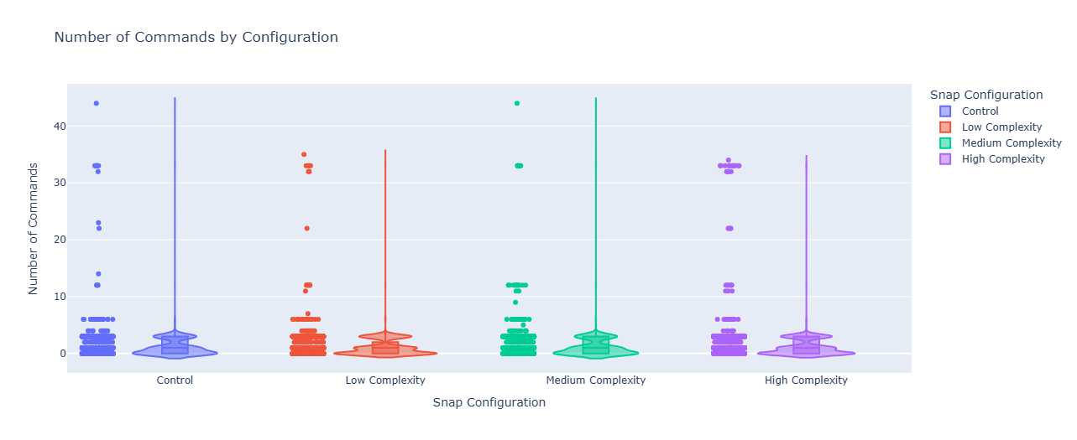
Figure 7 Number of commands for attackers in each session in the total dataset for each snap configuration.

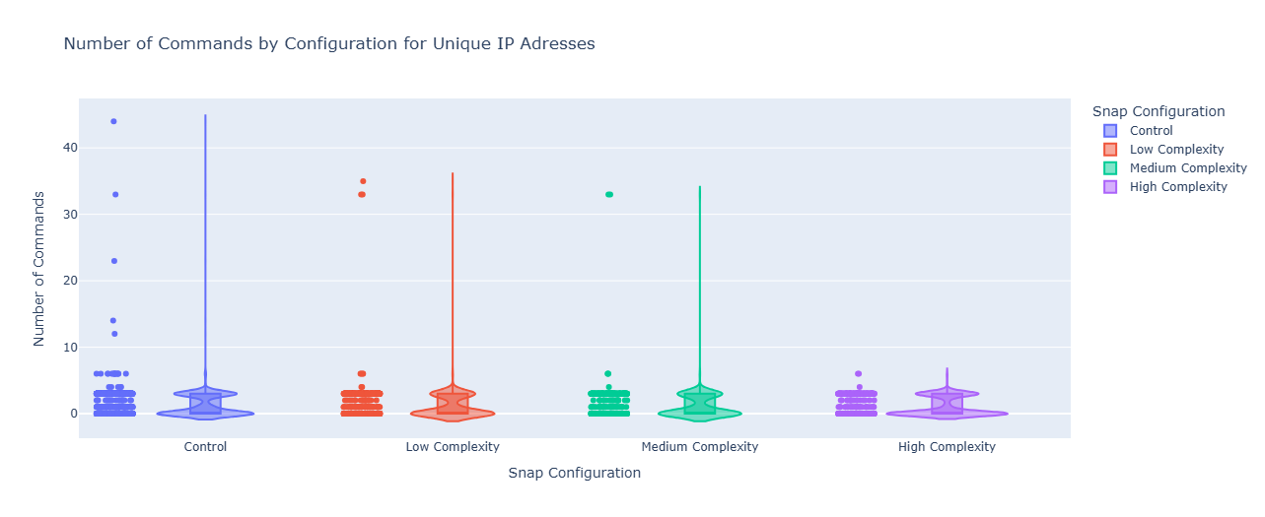
Figure 8 Number of commands for attackers in each session in the unique attacker dataset for each snap configuration.

Appendix B.IV
Table 1 Table of commonly used command groups and their frequency. The frequency relates to one unique attacker session for each commonly used phrase. It does not represent a portion of an attacker session using a specific command.
Commands Used | Frequency
uname -s -v -n -r -m, uname -a, uname -s | 8012
cd ~; chattr -ia .ssh; lockr -ia .ssh | 7235
apt | 205
cat && exit 100 || more && exit 101 || less && exit 102 || tee && exit 103 || tr x x && exit 104 || read v && echo -e "$v" && exit 105 || exit 113 | 279
cd ~; chattr -ia .ssh; lockr -ia .ssh; cd ~; chattr -ia .ssh; lockr -ia .ssh | 66
./oinasf; dd if=/proc/self/exe bs=22 count=1 || while read i; do echo $i; done < /proc/self/exe || cat /proc/self/exe; | 41
scp, wget | 181

Appendix C
Appendix C.I
The corresponding passwords used for each encrypted directory. The passwords for each folder were unique to simulate a real world situation and were divided into 3 categories: Low, Medium and Hard.
Folder | Low-complexity | Medium-complexity | Hard Complexity
Billing and Insurance 2019 | art | H3llo! | Xylo#9Rt!
Billing and Insurance 2020 | cat | L0ve#1 | Tuv#1Np$
Billing and Insurance 2021 | fun | C@ke4u | Pz$4Cxm!
Billing and Insurance 2022 | joy | H@ppy7 | Lmnop$7Tb!
Billing and Insurance 2023 | six | P@int5 | Qwert$3Zy!
Billing and Insurance 2024 | gym | W0rld# | Bx12$Qr!
Diabetes Study | key | D0g$me | Fdgh%9Vj!
Dr. Carter Johnson | yes | S0n#42 | Cdef#3Qr$
Dr. Jessica martinez | sis | N1ght# | Nopq#7Vm$
Samantha | eat | P1ckl$ | Zxy@3Tk%
Lauren | diy | F@mi1y | Rst#2Yq$
Sarah | mom | C@t123 | Hijk@5Xy!
Mental Health | ugh | J@zz99 | Jklm%5Bf!
Brian | tea | R1ver$ | Wqer#8Lp$
David | bed | C@ndy8 | Vx1!Jkq%
Micheal | abc | M0m$89 | Qw$5Dyz@O
EXTRA | car | B3ach# | Pz$4Cxm!
EXTRA | hot | T1ger! | Lmnop$7Tb!
Appendix C.II
Figure 1 - recyclingScript.sh
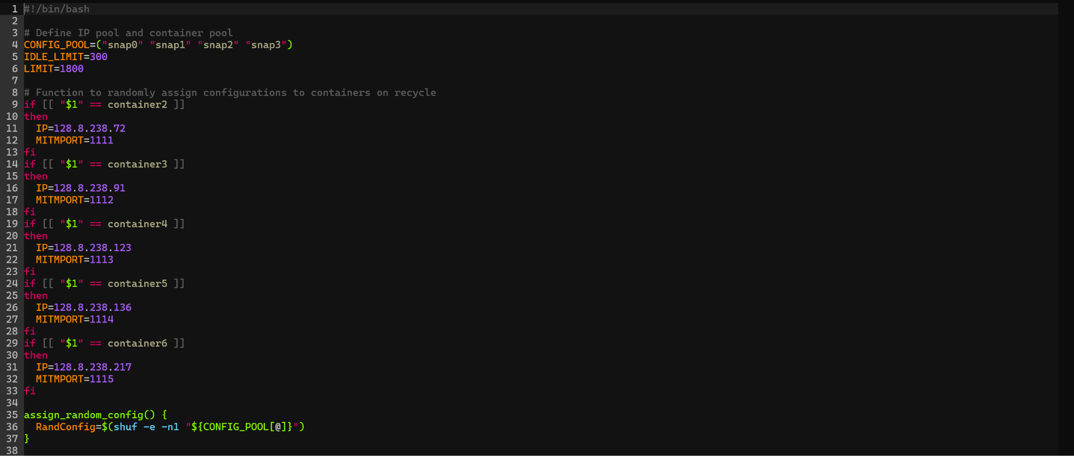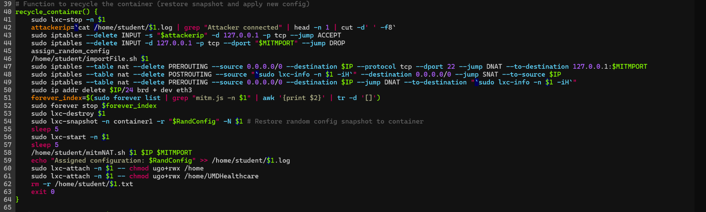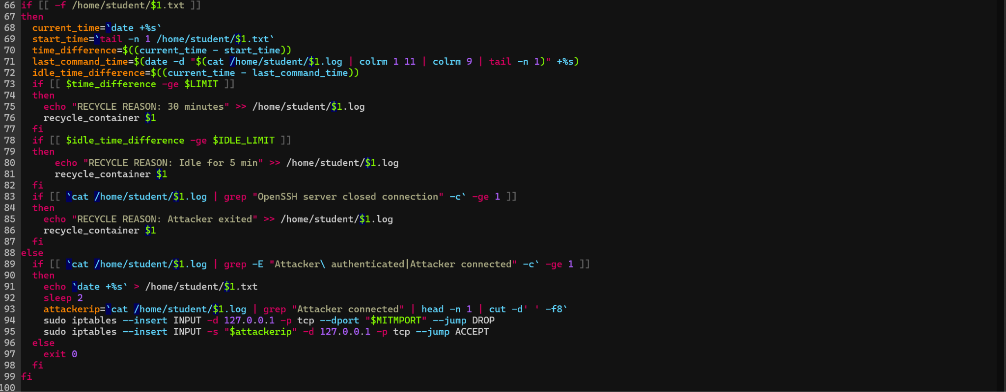

Figure 2 - importFile.sh
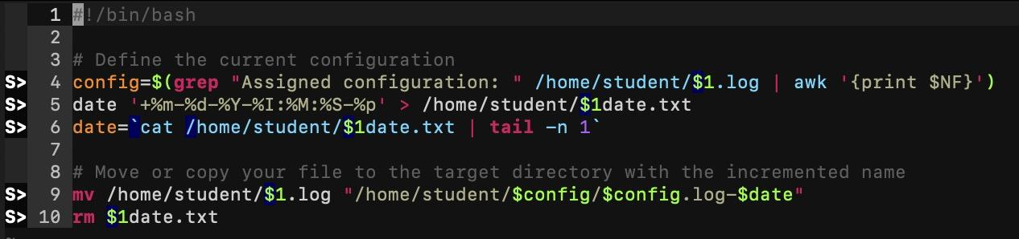
Figure 3 - container1Recyle.sh
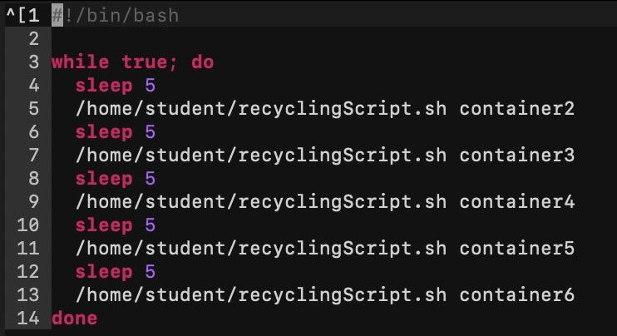

Figure 4 - cronSetup.sh
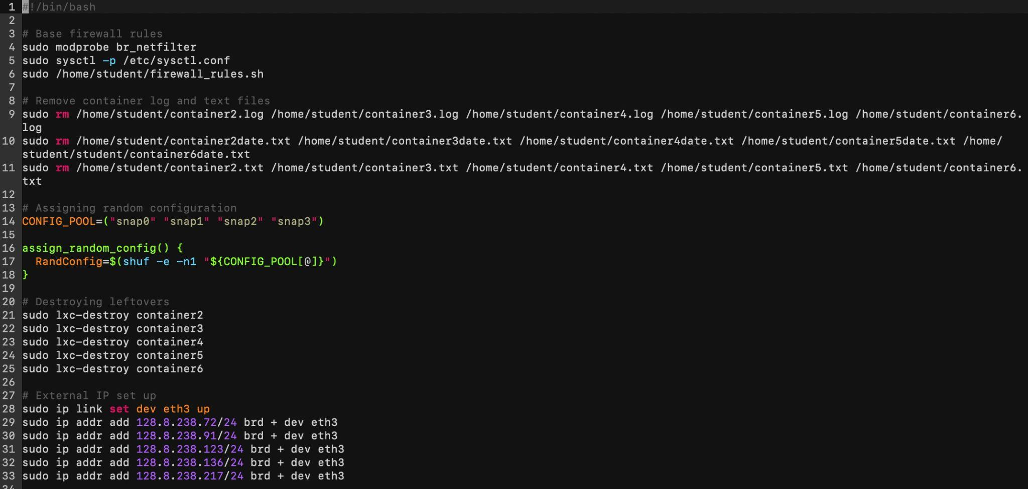
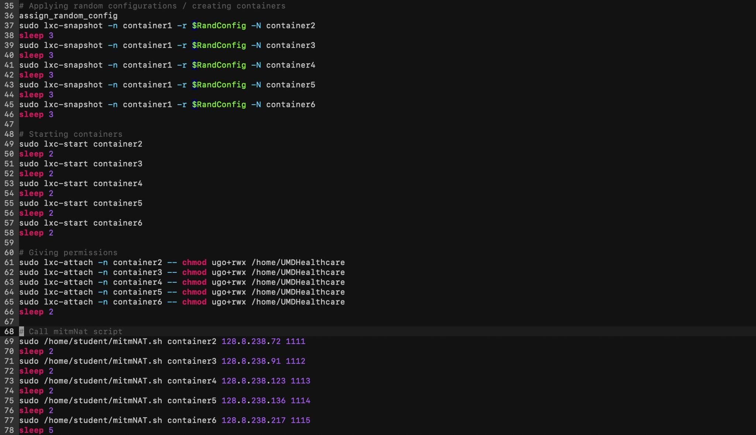

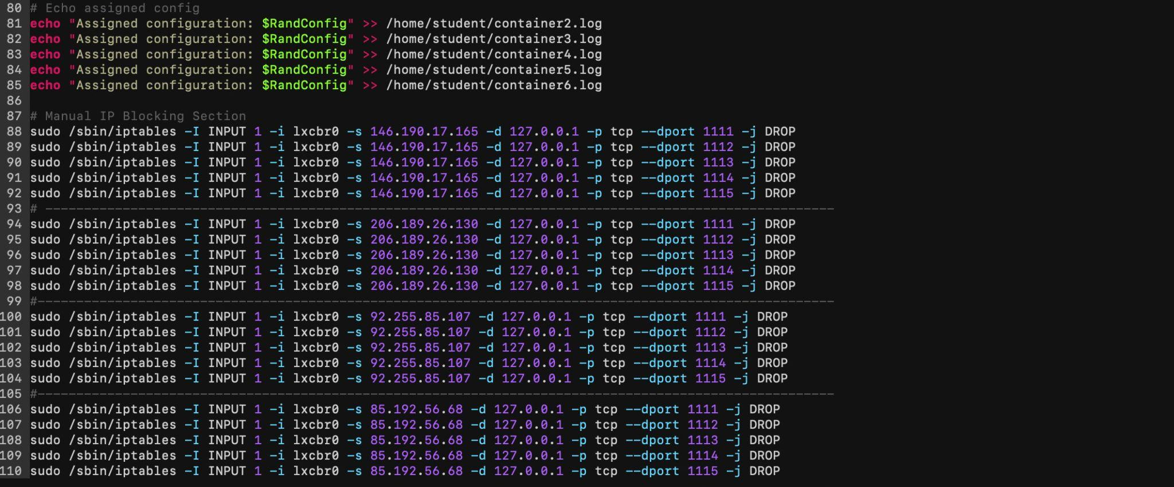
Figure 5 - mitmNAT.sh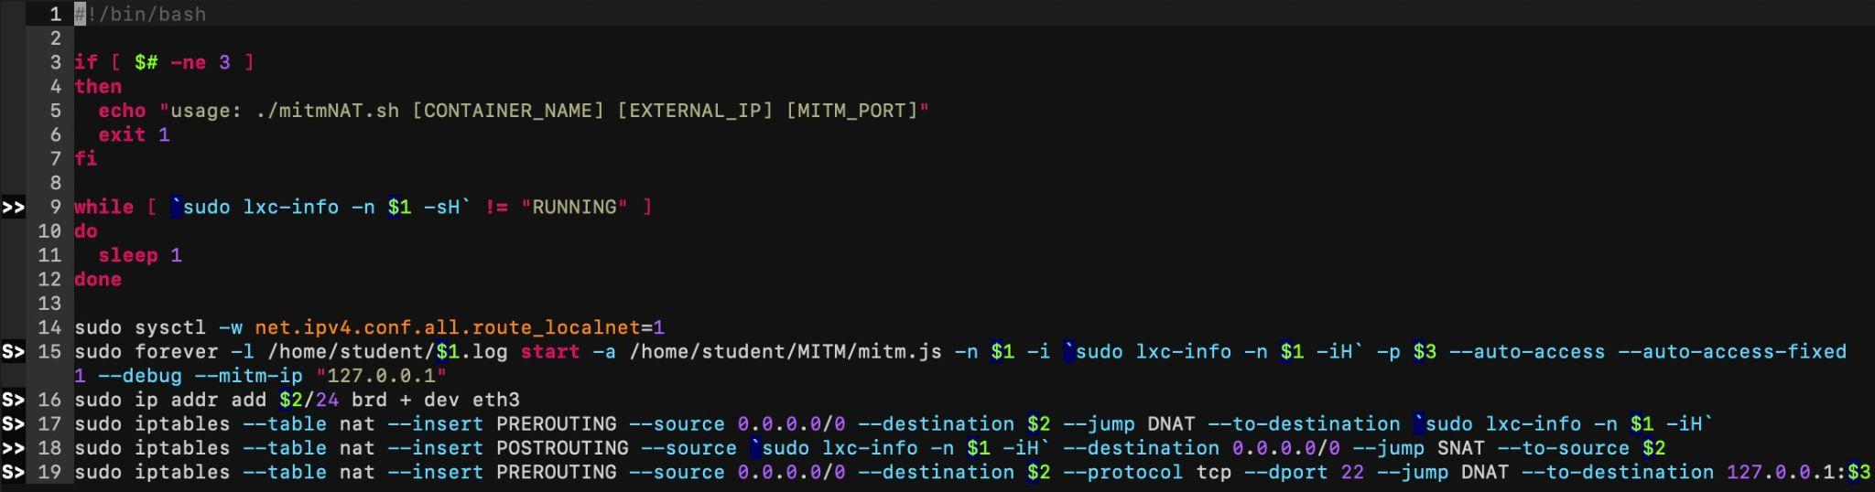
Figure 6 - parseLog.py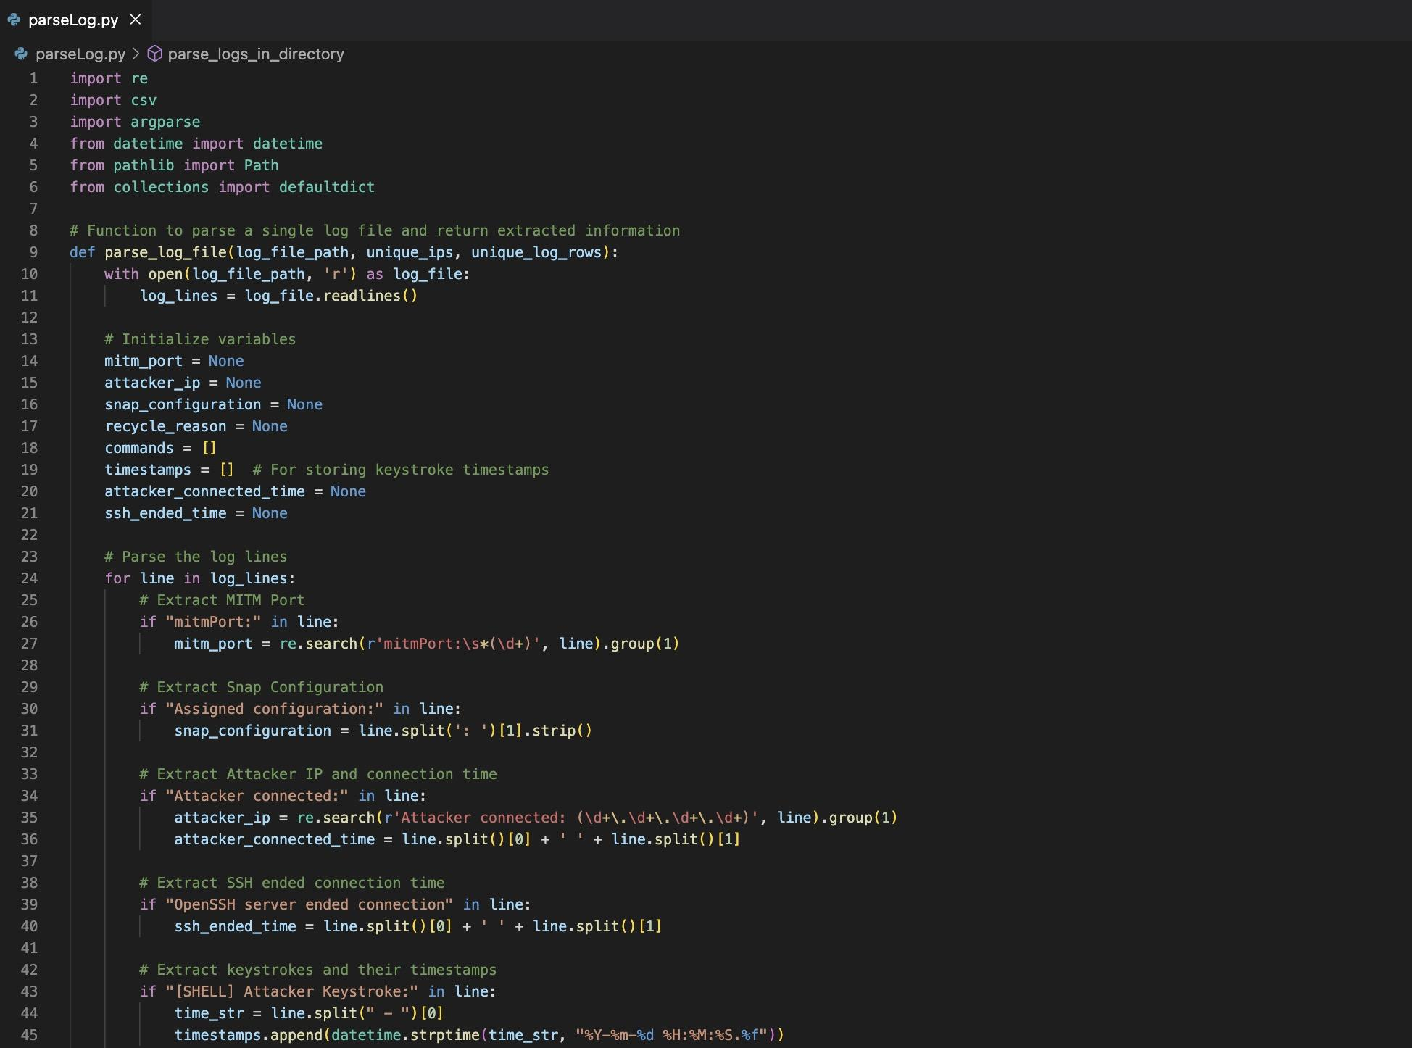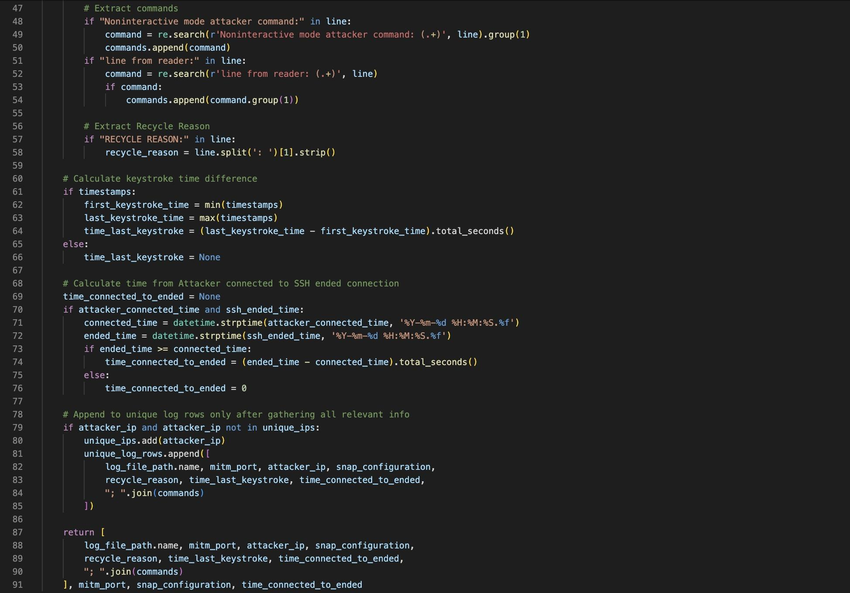
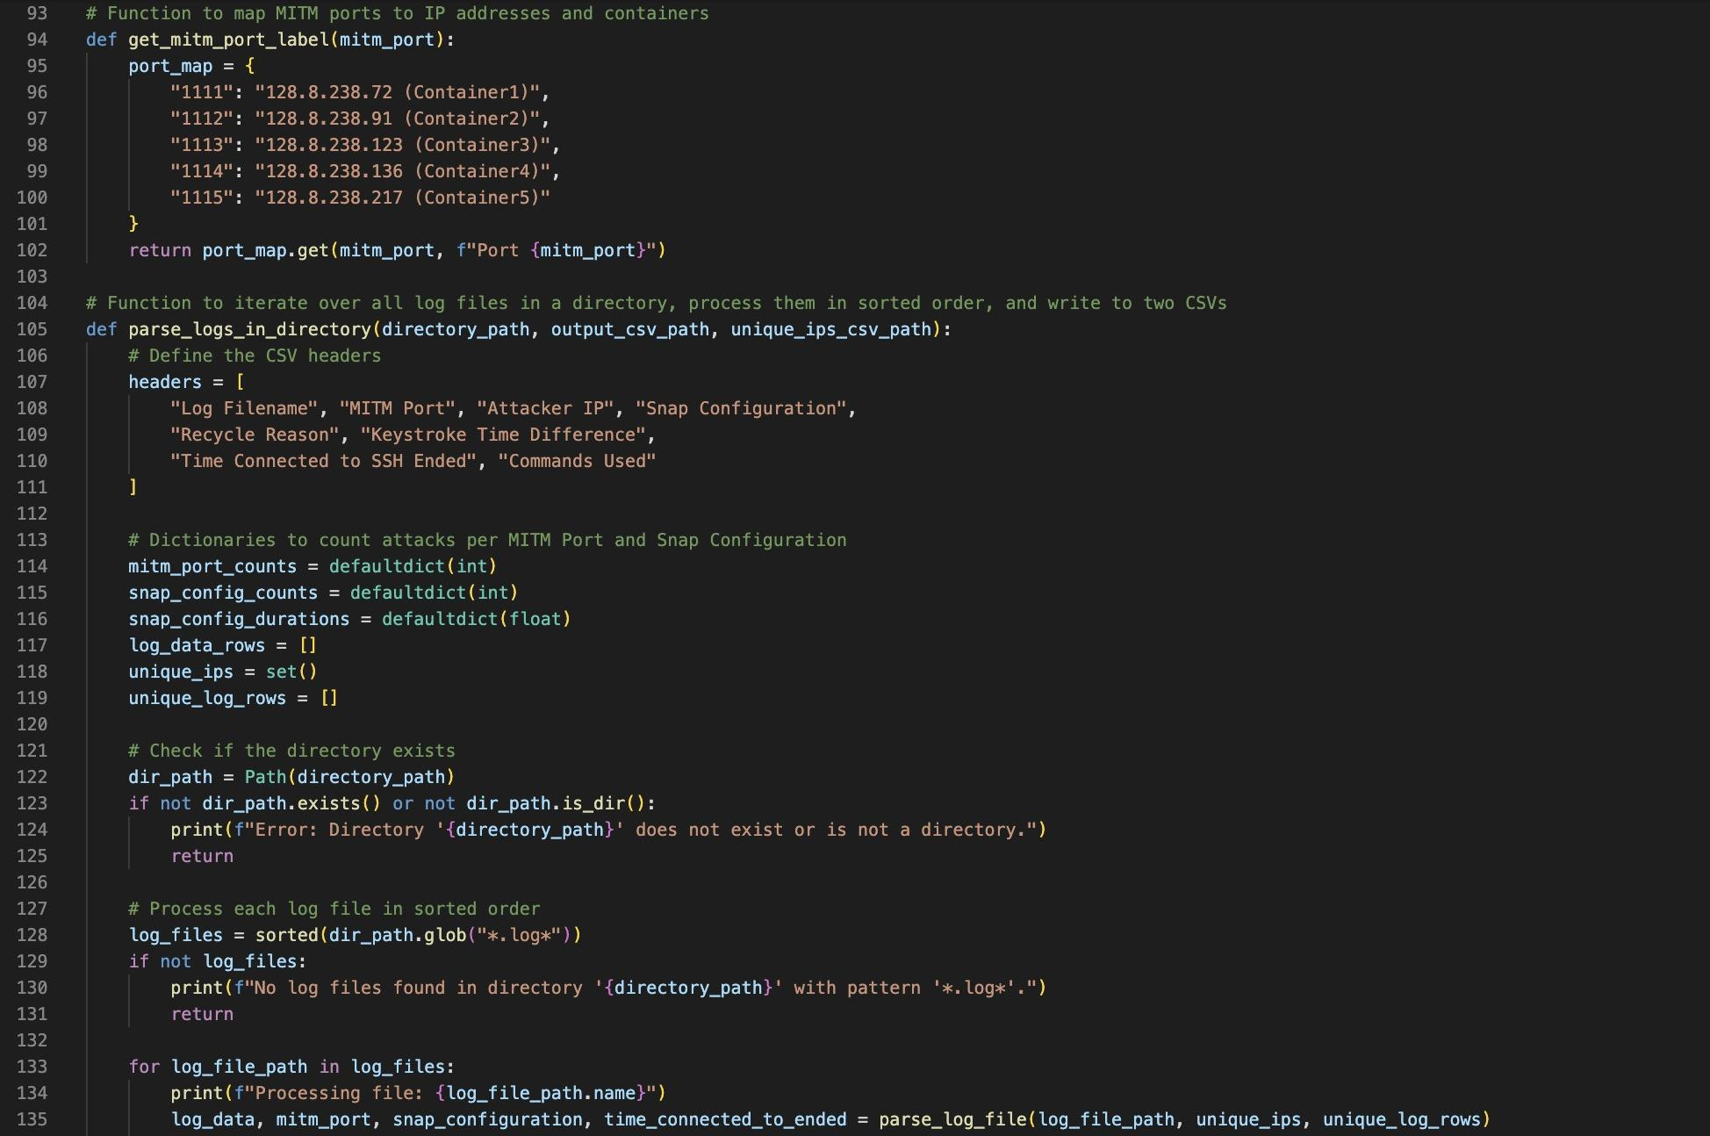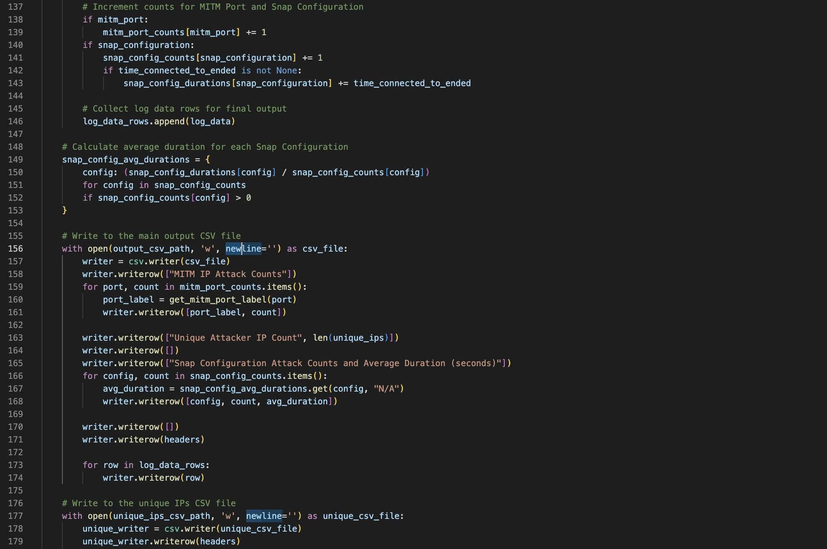
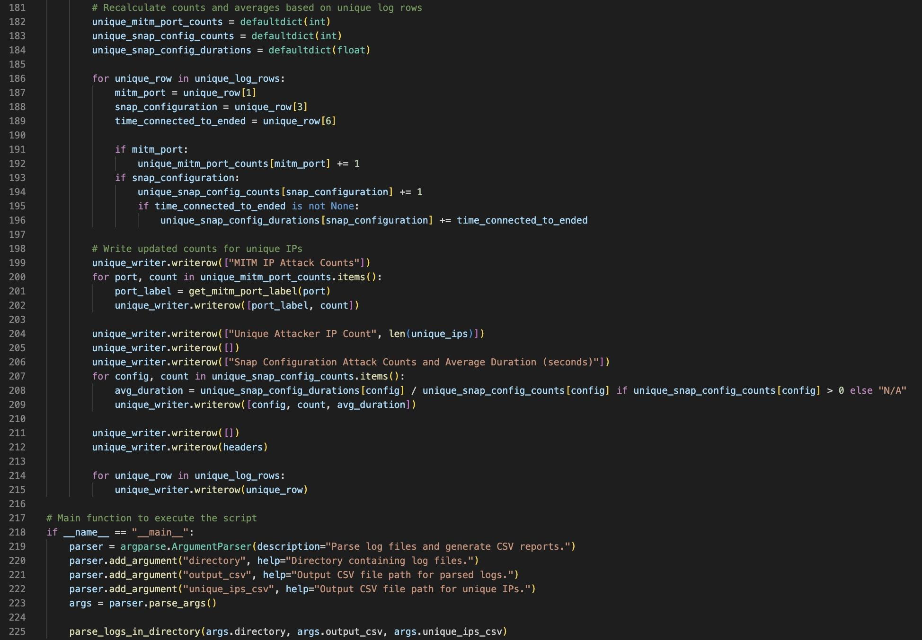

Appendix C.III

The Google colab notebook used to program all the graphs and perform the statistical analysis is linked below:

https://colab.research.google.com/drive/17fLM0MkrEfh7Q2DcRxHiUOGuNhm-4hKf#scrollTo=BL_tWK0R_ZIl

References
Cazier, Joseph A., and B. Dawn Medlin. “Password Security: An Empirical Investigation Into E-Commerce Passwords and Their Crack Times.” Information Systems Security, vol. 15, no. 6, Dec. 2006, pp. 45–55, doi:10.1080/10658980601051318.
Grassi, Paul A., et al. Digital Identity Guidelines: Revision 3. 22 June 2017, doi:10.6028/nist.sp.800-63-3.
Sahin, Cem Safak, et al. “General Framework for Evaluating Password Complexity and Strength.” arXiv (Cornell University), Jan. 2015, doi:10.48550/arxiv.1512.05814.
Yu, Fei, and Yulei Huang. “An Overview of Study of Password Cracking.” IEEE, Oct. 2015, doi:10.1109/csma.2015.12.

